Exercise 6

Shopping App UI using RAD Model

Name:R Praveen
Register Number:230701244

Introduction

Designing an engaging and simple user interface (UI) is essential for a smooth shopping experience. For this project, I implemented the Rapid Application Development (RAD) model to quickly prototype and improve the Ripokart Shopping App. This method focuses on fast development, early user feedback, and multiple iterations, making it ideal for creating user-friendly designs.
The Ripokart prototype was designed using Axure RP, covering the key screens like Home, Product Categories, Product Detail, and Order Detail. The UI simulates a real-world online shopping experience.

Applying the RAD Model to UI Design

Phase 1: Requirements Planning

In the planning stage, I identified the basic features needed for a simple shopping app.

Key Features:

- Search functionality to find products easily
- Category-wise product listing (e.g., Electronics, Toys)
- Product detail view with price and EMI options
- Order detail page to confirm delivery address and purchase
- Simple navigation with Buy buttons on each screen

Phase 2: User Design
Tool Used: Axure RP
Project Title: Ripokart Shopping App
Screens Designed:
- Home Page
  - App name "Ripokart" at the top
  - Hamburger menu for navigation
  - Search bar with magnifying glass icon and "Search" button
  - Big “Welcome” text to greet users
- Product Listing Page
  - Categories like "Electronics" and "Toys"
  - Product images under each category (e.g., Laptop, Mobile, Toys, Bicycle)
  - "Buy" button under each product for easy purchasing
- Product Detail Page
  - Enlarged product image
  - Detailed product pricing (e.g., ₹11,834/month EMI plan)
  - "Buy" button to move to order
- Order Detail Page
  - Selected product image displayed again
  - Address input box (example: Chrompet, Chennai)
  - Final "Buy" button to confirm the order

Phase 3: Construction

I created wireframes first and then added interactive elements to simulate the app flow.
Implementation Details:

- Navigation between Home → Categories → Product Details → Order Confirmation
- Search bar clickable, even though in this prototype it is non-functional
- "Buy" button on each page leads smoothly to the next step
- Scrollable address field on the order page

Phase 4: Cutover

Finally, I packaged the app prototype for demonstration and feedback.

Deployment:
- The interactive prototype was exported via Axure Cloud
- Presented to classmates and faculty members for review
- Collected feedback for future improvements like adding a payment gateway and order tracking feature

In this final phase, I prepared the design for review and presentation.

Deployment:

• The prototype was exported/shared using Axure Cloud

• Demonstrated to classmates and instructors for feedback

Website: https://www.axure.com (or your tool’s website)

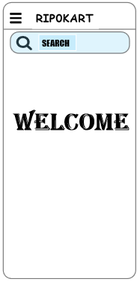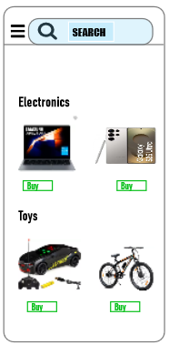

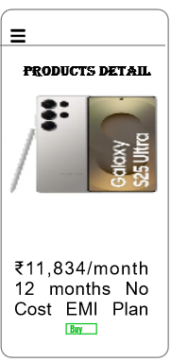

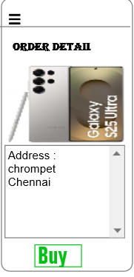

Conclusion

This project provided hands-on experience using the RAD model to build a Shopping delivery app interface. With the help of Axure RP was able to quickly design, prototype, and refine the UI through feedback and iterations. The process showed how essential good design and user-centric features are for creating seamless digital experiences.

